HTML –Non-Major Elective

**UNIT-I**

Internet

The Internet is a massive network of networks, a networking infrastructure. It connects millions of computers together globally, forming a network in which any computer can communicate with any other computer as long as they are both connected to the Internet.

The Internet is a global [network](http://www.webopedia.com/TERM/N/network.htm) connecting millions of [computers](http://www.webopedia.com/TERM/C/computer.htm). More than 100 countries are linked into exchanges of [data](http://www.webopedia.com/TERM/D/data.htm), news and opinions.

**The Internet Protocols**

**FTP:(File transfer protocol)**

- One of the most oldest and probably the most popular protocol to be used to move files on the Internet.

**TCP/IP:(Transmission Control Protocol and Internet Protocol)**

- The low-level communications protocol that holds the Internet together.

- It provides means to allows two software on difference machines on the Internet find each other, rendezvous, and transfer data.- It provides the essential service of making sure that each piece of data is transferred in the correct sequence and without error.

**SMTP: (the e-mail message protocol)**

- A protocol to allow two users to communicate through e-mail messages over the Internet.

**NNTP: (Net News Transfer Protocol)**

- A protocol, which can be used to access or transfer Usenet news over the Internet.

**Telnet:** - The traditional teletype-style communications protocol for communicating with text-based information services.

**The World Wide Web: History**

March, 1989, Tim Berners-Lee of Geneva s European Particle Physics Laboratory (CERN) circulated a proposal to develop a hypertext system for global information sharing in High Energy Physics community.

(http://info.cern.ch/hypertext/WWW/TheProject.html)

The World Wide Web project began to take shape at the beginning of 1991.

October 1991, the gateways for WAIS search (a crucial development for the Web s future as search as well as a browsing tool), before the end of 1991, CERN announced the Web to the High Energy Physics community in general.

Essentially, 1992 was a developmental year. In March of 1993, WWW traffic clocked in at 0.1 percent of total Internet backbone traffic. In July of 1994, CERN began to turn over the Web project to a new group called the W3 organization, a joint venture between CERN and MIT to develop the Web further.

**The World Wide Web: HTML**

HTML is a simplified derivative of SGML, or Standard Generalized Markup language. Its code can be used to make documents readable across a variety of platforms and software. Like SGML, HTML operates through a series of codes placed within an ASCII doc. These codes are translated by a WWW client such as Lynx, Mosaic,Cello, Viola, or MacWeb into specific kinds of formats to be displayed on the screen.

Items include in a HTML page are: links, lists, headings, titles, images, forms, and maps.

Due to the limitation of HTML documents, now more advanced technologies are introduced to enrich its functions, such as , JavaScript, ActiveX, VML, SVG

**The World Wide Web: HTTP**

HTTP stands for Hypertext Transfer Protocol.

It is a simple data transfer protocol that binds the Web together.

It supports the communications between a web client (browser) and its web server.

It consists of a set of messages and replies for both servers and browsers.

It treats documents, files, menus, and graphics as objects.

It relies on the Universal resource identifier (URI), enclosed in the universal resource locator (URL), to identify files.

It uses the Internet s TCP/IP network protocol.

(http://info.cern.ch/hypertext/WWW/Protocols/HTTP/HTTP2.html)

**Internet Service Providers (ISPs)**

Companies that provide connectivity to the Internet are

known as Internet Service Providers. Many ISPs

provide a complete range of services, e.g. they will

· Connect networks (or individual hosts) to the

**Internet**

Provide services for their customers such as e-mail, network news and Web access. Provide support services such as Web hosting Other ISPs may, however, choose to concentrate on.particular services

**WWW**

The World Wide Web, or simply Web, is a way of accessing information over the medium of the Internet. It is an information-sharing model that is built on top of the Internet.

*The Internet* is **not** synonymous with [*World Wide Web*](http://www.webopedia.com/TERM/W/World_Wide_Web.html)

Web Browsers

The purpose of a web browser is to read HTML documents and display them as web pages.

Web browsers are Google Chrome, Internet Explorer, Firefox, Safari etc

The browser does not display the HTML tags, but uses the tags to determine how the content of the HTML page is to be presented/displayed to the user:

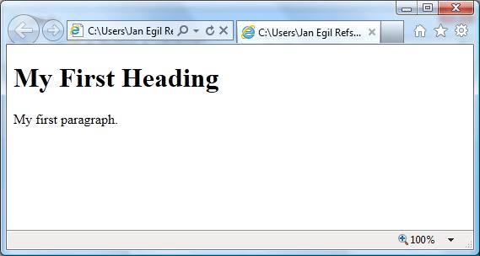

**What is web page?**

A **web page**  is a [web document](http://en.wikipedia.org/wiki/Web_document) that is suitable for the [World Wide Web](http://en.wikipedia.org/wiki/World_Wide_Web) and the [*web browser*](http://en.wikipedia.org/wiki/Web_browser). A web browser displays a web page on a [monitor](http://en.wikipedia.org/wiki/Computer_display) or [mobile device](http://en.wikipedia.org/wiki/Mobile_device). The web page is what displays, but the term also refers to a [computer file](http://en.wikipedia.org/wiki/Computer_file), usually written in [HTML](http://en.wikipedia.org/wiki/HTML) or comparable [markup language](http://en.wikipedia.org/wiki/Markup_language),

A [*static web page*](http://en.wikipedia.org/wiki/Static_web_page) is delivered exactly as stored, as [web content](http://en.wikipedia.org/wiki/Web_content) in the web server's [file system](http://en.wikipedia.org/wiki/File_system), while a [*dynamic web page*](http://en.wikipedia.org/wiki/Dynamic_web_page) is generated by a [web application](http://en.wikipedia.org/wiki/Web_application) that is driven by [server-side software](http://en.wikipedia.org/wiki/Server-side_scripting) or [client-side scripting](http://en.wikipedia.org/wiki/Client-side_scripting). Dynamic web pages help the browser (the client) to enhance the web page through user input to the server.

A *web page*, as an information set, can contain numerous types of information, which is able to be seen, heard or interact by the [end user](http://en.wikipedia.org/wiki/End-user):

**Perceived** (rendered) information:

* *Textual information*: with diverse render variations.
* *Non-textual information*:
  + *Static images* may be [raster graphics](http://en.wikipedia.org/wiki/Raster_graphics), typically [GIF](http://en.wikipedia.org/wiki/Graphics_Interchange_Format), [JPEG](http://en.wikipedia.org/wiki/JPEG) or [PNG](http://en.wikipedia.org/wiki/Portable_Network_Graphics); or [vector formats](http://en.wikipedia.org/wiki/Vector_graphics) such as [SVG](http://en.wikipedia.org/wiki/Scalable_Vector_Graphics) or [Flash](http://en.wikipedia.org/wiki/Adobe_Flash).
  + *Animated images* typically [Animated GIF](http://en.wikipedia.org/wiki/Animated_gif) and [SVG](http://en.wikipedia.org/wiki/Scalable_Vector_Graphics), but also may be [Flash](http://en.wikipedia.org/wiki/Adobe_Flash), [Shockwave](http://en.wikipedia.org/wiki/Adobe_Shockwave), or [Java applet](http://en.wikipedia.org/wiki/Java_applet).
  + [Audio](http://en.wikipedia.org/wiki/Audio_frequency), typically [MP3](http://en.wikipedia.org/wiki/MP3), [ogg](http://en.wikipedia.org/wiki/Ogg" \o "Ogg) or various proprietary formats.
  + [Video](http://en.wikipedia.org/wiki/Video), WMV (Windows), RM (RealMedia), FLV (Flash Video), MPG, MOV (QuickTime)
* *Interactive information*: see [interactive media](http://en.wikipedia.org/wiki/Interactive_media).
  + For "on page" interaction:
    - *Interactive text*: see [DHTML](http://en.wikipedia.org/wiki/DHTML).
    - *Interactive illustrations*: ranging from "click to play" images to [games](http://en.wikipedia.org/wiki/Browser_game), typically using *script orchestration*, [Flash](http://en.wikipedia.org/wiki/Adobe_Flash), [Java applets](http://en.wikipedia.org/wiki/Java_applet), [SVG](http://en.wikipedia.org/wiki/Scalable_Vector_Graphics), or [Shockwave](http://en.wikipedia.org/wiki/Adobe_Shockwave).
    - *Buttons*: forms providing alternative interface, typically for use with *script orchestration* and DHTML.
  + For "between pages" interaction:
    - *Hyperlinks*: standard "change page" reactivity.
    - *Forms*: providing more interaction with the server and server-side databases.

**Internal** (hidden) information:

* *Comments*
* *Linked Files through Hyperlink (Like DOC, XLS, PDF, etc.)*
* *Metadata* with [semantic meta-information](http://en.wikipedia.org/wiki/Meta_tags), Charset information, [Document Type Definition](http://en.wikipedia.org/wiki/Document_Type_Definition) (DTD), etc.
* *Diagramation and style information*: information about rendered items (like image size attributes) and visual specifications, as [Cascading Style Sheets](http://en.wikipedia.org/wiki/Cascading_Style_Sheets) (CSS).
* *Scripts*, usually [JavaScript](http://en.wikipedia.org/wiki/JavaScript), complement interactivity and functionality.

**Navigation**

There are several basic styles of navigation. In general, the styles are identified by position and orientation on a page. They include:

* Top
* Left Side
* Right Side
* Bottom
* Horizontal
* Vertical

Top and side navigation are the most common. Right side navigation is relatively rare. Because it is so rare, it should generally be avoided because Web visitors are not used to it.

Bottom navigation is used when pages are long. This eliminates the need for the page visitor having to scroll back to the top of a page to access a link.

Bottom navigation using standard text links is often used on pages where rollover navigation is used elsewhere. Search engine robots often find it difficult, or impossible, to follow the image-swapping effects of rollover navigation. Standard text navigation allows the robots to easily catalog a page and follow the links.

On complicated sites navigation can be divided into primary and secondary categories. In the example to the right, the top navigation is primary. It is identical from page to page.

The side navigation is secondary. Each group of sub pages under the various primary navigation categories has its own custom navigation on the side. While the primary navigation is accomplished by image mapping, the secondary navigation consists of text links. The text links can be easily updated if necessary.

Putting all the possible links, both primary and secondary, on one page would make the page far too complicated and nearly impossible to use.

Unit-II

What is HTML?

HTML is a language for describing web pages.

* HTML stands for **H**yper **T**ext **M**arkup **L**anguage
* HTML is a **markup**language
* A markup language is a set of markup**tags**
* The tags **describe** document content
* HTML documents containHTML**tags** and plain **text**
* HTML documents are also called**web pages**

HTML Tags

HTML markup tags are usually called HTML tags.

* HTML tags are keywords (tag names) surrounded by **angle brackets**like <html>
* HTML tags normally **come in pairs** like <p> and </p>
* The first tag in a pair is the **start tag,** the second tag is the **end tag**
* The end tag is written like the start tag, with a **slash** before the tag name
* Start and end tags are also called **opening tags** and **closing tags**

<tagname> content </tagname>

HTML Page Structure

Below is a visualization of an HTML page structure:

<html>

<body>

<h1>This is a heading</h1>

<p>This is a paragraph.</p>

<p>This is another paragraph.</p>

</body>

</html>

HTML Versions

Since the early days of the web, there have been many versions of HTML:

|  |  |
| --- | --- |
| **Version** | **Year** |
| HTML | 1991 |
| HTML+ | 1993 |
| HTML 2.0 | 1995 |
| HTML 3.2 | 1997 |
| HTML 4.01 | 1999 |
| XHTML | 2000 |
| HTML5 | 2012 |

The <!DOCTYPE> Declaration

The <!DOCTYPE> declaration helps the browser to display a web page correctly.

There are many different documents on the web, and a browser can only display an HTML page 100% correctly if it knows the HTML version and type used.

Common Declarations

HTML5

<!DOCTYPE html>

HTML 4.01

<!DOCTYPE HTML PUBLIC "-//W3C//DTD HTML 4.01 Transitional//EN"  
"http://www.w3.org/TR/html4/loose.dtd">

XHTML 1.0

<!DOCTYPE html PUBLIC "-//W3C//DTD XHTML 1.0 Transitional//EN"  
"http://www.w3.org/TR/xhtml1/DTD/xhtml1-transitional.dtd">

For a complete list of document type declarations, go to our [DOCTYPE Reference](http://www.w3schools.com/tags/tag_doctype.asp).

Basic Structure of HTML

DocumentType<HTML></HTML>  
Title<TITLE></TITLE>  
Header<HEAD></HEAD>  
Body <BODY> </BODY>

•HTML document begins and ends with HTML tag i.e. <HTML> </HTML>  
Here <HTML> indicates the browser that it is a HTML document and </HTML> tells the browser that HTML document is completed.

•HeaderTagi.e.<HEAD></HEAD>  
Header Tag does not contain any text, it only contains the Title Tag in it.

•Titletagi.e.<TITLE></TITLE>  
Anything written between this tag is not displayed on the screen but it is used to identify the Webpage.

•Bodytagi.e.<BODY></BODY>  
This is the main part of HTML document. The content which is to be displayed on screen as webpage should be written here. Body Tag contains the text as well as various tags but only the text will be displayed on Webpage.

A simple example

<html>

<head>

<title>   My First WEB PAGE </title>

<body>

HTML is Hyper Text Markup Language

</body></html>

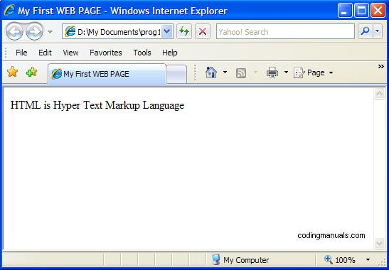

HTML Editors

Write HTML Using Notepad or TextEdit

HTML can be edited by using a professional HTML editor like:

* Adobe Dreamweaver
* Microsoft Expression Web
* CoffeeCup HTML Editor
* However, for learning HTML we recommend a text editor like Notepad (PC) or TextEdit (Mac).We believe using a simple text editor is a good way to learn HTML.Follow the 4 steps below to create your first web page with Notepad.

Step 1: Open Notepad

To open Notepad in Windows 7 or earlier:

Click **Start** (bottom left on your screen). Click **All Programs**. Click **Accessories**. Click **Notepad**.

To open Notepad in Windows 8 or later:

Open the **Start Screen** (the window symbol at the bottom left on your screen). Type **Notepad**.

Step 2: Write or copy some HTML into Notepad.

Example

<!DOCTYPE html>  
<html>  
<body>  
  
<h1>My First Heading</h1>  
  
<p>My first paragraph.</p>  
  
</body>  
</html>

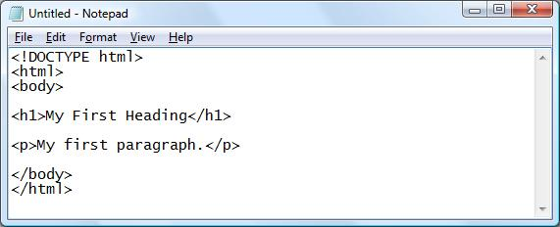

Step 3: Save the HTML Page

Save the file on your computer.

Select **File -> Save as** in the Notepad menu.

When saving an HTML file, use either the .htm or the .html file extension. There is no difference, it is entirely up to you.

Step 4: View HTML Page in Your Browser

Double-click your saved HTML file, and the result will look much like this:



HTML Elements

HTML documents are defined by HTML elements.

HTML Elements

An HTML element is everything from the start tag to the end tag:

|  |  |  |
| --- | --- | --- |
| **Start tag \*** | **Element content** | **End tag \*** |
| <p> | This is a paragraph | </p> |
| <a href="default.htm"> | This is a link | </a> |
| <br> |  |  |

**\*** The start tag is often called the **opening tag**. The end tag is often called the **closing tag**.

HTML Element Syntax

* An HTML element starts with a **start tag / opening tag**
* An HTML element ends with an **end tag / closing tag**
* The **element content** is everything between the start and the end tag
* Some HTML elements have **empty content**
* Empty elements are **closed in the start tag**
* Most HTML elements can have **attributes**

Nested HTML Elements

Most HTML elements can be nested (can contain other HTML elements).

HTML documents consist of nested HTML elements.

HTML Document Example

<!DOCTYPE html>  
<html>  
  
<body>  
<p>This is my first paragraph.</p>  
</body>  
  
</html>

The example above contains 3 HTML elements.

HTML Example Explained

**The <p> element:**

<p>This is my first paragraph.</p>

The <p> element defines a paragraph in the HTML document.  
The element has a start tag <p> and an end tag </p>.  
The element content is: This is my first paragraph.

**The <body> element:**

<body>  
<p>This is my first paragraph.</p>  
</body>

The <body> element defines the body of the HTML document.  
The element has a start tag <body> and an end tag </body>.  
The element content is another HTML element (a p element).

**The <html> element:**

<html>  
  
<body>  
<p>This is my first paragraph.</p>  
</body>  
  
</html>

The <html> element defines the whole HTML document.  
The element has a start tag <html> and an end tag </html>.  
The element content is another HTML element (the body element).

Don't Forget the End Tag

Some HTML elements might display correctly even if you forget the end tag:

<p>This is a paragraph  
<p>This is a paragraph

The example above works in most browsers, because the closing tag is considered optional.

Never rely on this. Many HTML elements will produce unexpected results and/or errors if you forget the end tag .

Empty HTML Elements

HTML elements with no content are called empty elements.

<br> is an empty element without a closing tag (the <br> tag defines a line break).

**Tip:** In XHTML, all elements must be closed. Adding a slash inside the start tag, like <br />, is the proper way of closing empty elements in XHTML (and XML).

HTML Tip: Use Lowercase Tags

HTML tags are not case sensitive: <P> means the same as <p>. Many web sites use uppercase HTML tags.

W3Schools use lowercase tags because the World Wide Web Consortium (W3C) **recommends** lowercase in HTML 4, and **demands** lowercase tags in XHTML.

<!DOCTYPE html>

<html>

<body>

<p><b>This text is bold</b></p>

<p><strong>This text is strong</strong></p>

<p><em>This text is emphasized</em></p>

<p><i>This text is italic</i></p>

<p><small>This text is small</small></p>

<p>This is<sub> subscript</sub> and <sup>superscript</sup></p>

</body>

</html>

**This text is bold**

**This text is strong**

This text is emphasized

*This text is italic*

This text is small

This issubscript and superscript

**<strike> tag**

The <strike> tag is not supported in HTML5. Use the [<del>](http://www.w3schools.com/tags/tag_del.asp) tag instead.

The <strike> tag defines strikethrough text.

Example

Strikethrough text can be marked up as follows:

<p>Version 2.0 is <strike>not yet available!</strike> now available!</p>

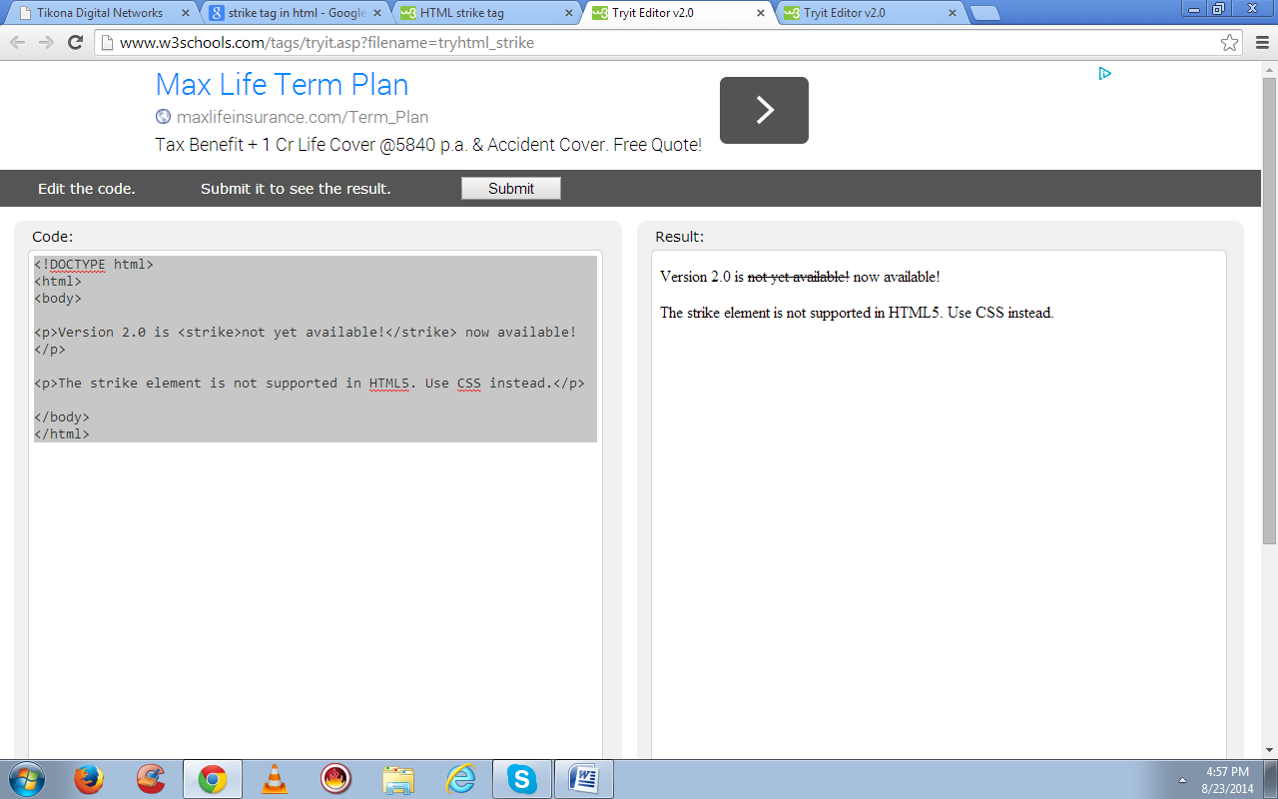

HTML <font> Tag. Not Supported in HTML5.

Example

Specify the font size, font face and color of text:

<font size="3" color="red">This is some text!</font>  
<font size="2" color="blue">This is some text!</font>  
<font face="verdana" color="green">This is some text!</font>

[**Try it Yourself**](http://www.w3schools.com/tags/tryit.asp?filename=tryhtml_font)

Definition and Usage

The <font> tag is not supported in HTML5. Use CSS instead.

The <font> tag specifies the font face, font size, and color of text.

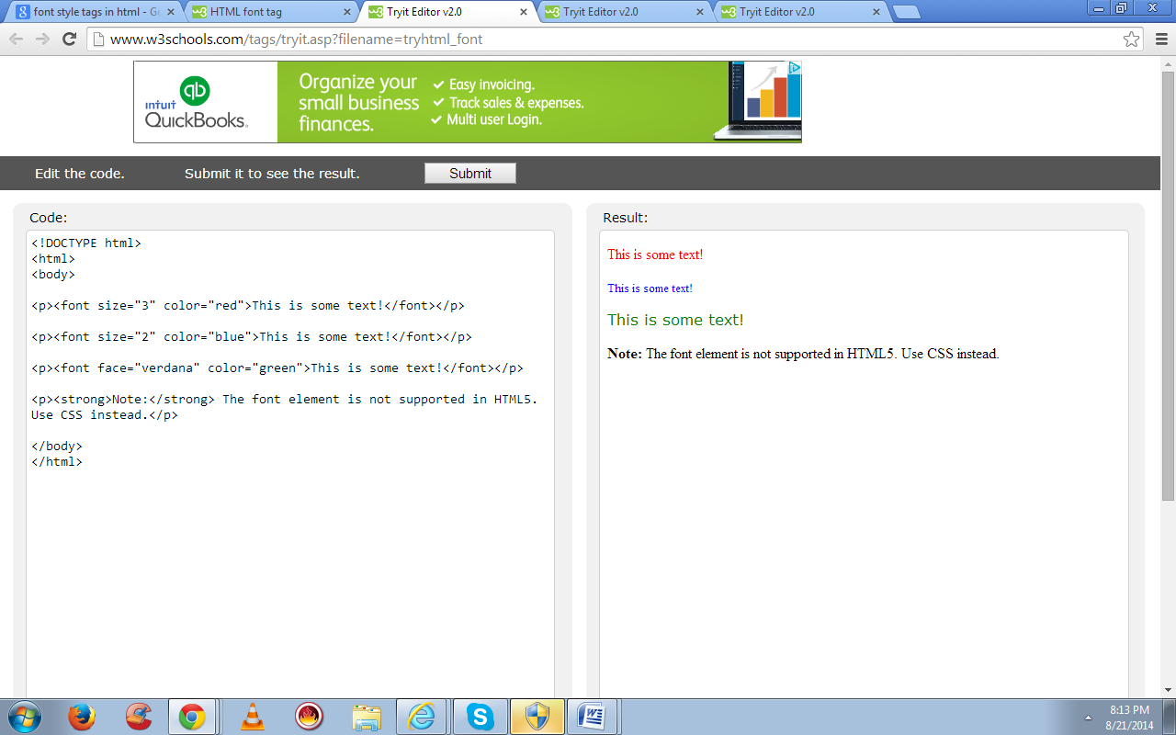

**Unit-III**

# HTML Lists

The most common HTML lists are ordered and unordered lists:

## HTML Lists

|  |  |
| --- | --- |
| An ordered list:  1. The first list item 2. The second list item 3. The third list item | An unordered list:  * List item * List item * List item |

## HTML Unordered Lists

An unordered list starts with the <ul> tag. Each list item starts with the <li> tag.

The list items are marked with bullets (typically small black circles).

<ul>  
<li>Coffee</li>  
<li>Milk</li>  
</ul>

How the HTML code above looks in a browser:

* Coffee
* Milk

## HTML Ordered Lists

An ordered list starts with the <ol> tag. Each list item starts with the <li> tag.

The list items are marked with numbers.

<ol>  
<li>Coffee</li>  
<li>Milk</li>  
</ol>

How the HTML code above looks in a browser:

1. Coffee
2. Milk

## HTML Description Lists

A description list is a list of terms/names, with a description of each term/name.

The <dl> tag defines a description list.

The <dl> tag is used in conjunction with <dt> (defines terms/names) and <dd> (describes each term/name):

<dl>  
<dt>Coffee</dt>  
<dd>- black hot drink</dd>  
<dt>Milk</dt>  
<dd>- white cold drink</dd>  
</dl>

How the HTML code above looks in a browser:

Coffee

- black hot drink

Milk

- white cold drink

[**What are List Tags?**](http://www.codingmanuals.com/html-tutorials/what-are-list-tags/)

* Ordered list tag  
  List items are displayed using bullets.
* Unordered list tag  
  List items are displayed using numbers.

Example: [source](http://www.codingmanuals.com/tutorials/html-tutorials/#viewSource) program

01.<html>

02.<head>

03.<title>   my first web page </title></head>

04.<body>

05.<ol>

06.<h1>list of HTML tags</h1>

07.<li> Header tag</li>

08.<li>bold tag</li>

09.<li> Italics tag</li>

10.<li>underline tag</li>

11.<!-- this is an example of ordered list tag--></ol>

12.<hr />

13.<ul>

14.<h1>list of HTML tags</h1>

15.<li>Header tag</li>

16.<li>bold tag</li>

17.<li>Italic tag</li>

18.<li>underline tag</li>

19.<!-- this is an example of unordered list tag --></ul>

20.</body>

21.</html>

Output:  
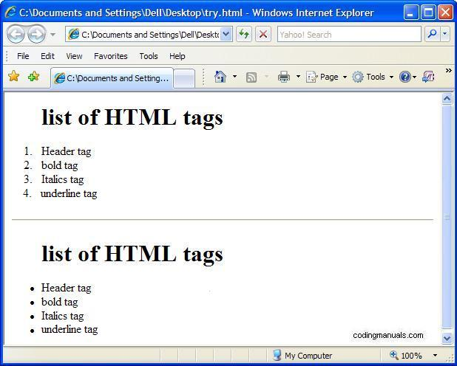

## HR and BR

## Line Break <br>:

## Line Break Tag as name indicates it is used to tell the browser that the line has ended. BR is an Example of single tags in HTML (Tags which do not have ending tags)

## Horizontal Rule <hr>:

## Horizontal Rule Tag will give you a thin black line across the page. It has few basic elements.

## 1) Size: it sets length of the horizontal rule in pixels or in % of page width. 2) Align : it aligns the horizontal rule to left, right, and center. 3) Width: It specifies the width of the horizontal rule.

Sample Program:

01.<html>

02.<head>

03.<title>Program</title></head>

04.<body>

05.<p>Statement<br>can<br>be<br>broken <br>using line break tag

06.<hr align =left  size="2" width="50%" >

07.<p> Web Page can be divided using horizontal rule tag

08.</body>

09.</html>

output:

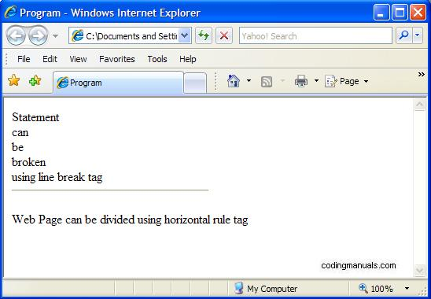

**Heading**   
There is tag for various headings in HTML known as Heading tag ranging from h1 to h6 where h1 is for most important and h6 is for least important.Example:

01.<html>

02.<head>

03.<title>   Heading Example </title></head>

04.<body>

05.<h1>Heading tag </h1>

06.<h2>Heading tag </h2>

07.<h3>Heading tag </h3>

08.<h4>Heading tag </h4>

09.<h5>Heading tag </h5>

10.<h6>Heading tag </h6>

11.</body>

12.</html>

Output:  
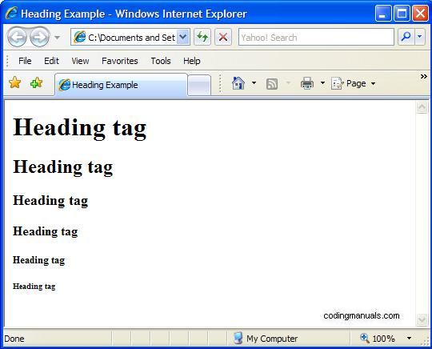

HTML Images - The <img> Tag and the Src Attribute

In HTML, images are defined with the <img> tag.

The <img> tag is empty, which means that it contains attributes only, and has no closing tag.

To display an image on a page, you need to use the src attribute. Src stands for "source". The value of the src attribute is the URL of the image you want to display.

**Syntax for defining an image:**

<img src="*url*" alt="*some_text*">

The URL points to the location where the image is stored. An image named "boat.gif", located in the "images" directory on "www.w3schools.com" has the URL: http://www.w3schools.com/images/boat.gif.

The browser displays the image where the <img> tag occurs in the document. If you put an image tag between two paragraphs, the browser shows the first paragraph, then the image, and then the second paragraph.

**HTML Images - The Alt Attribute**

The required alt attribute specifies an alternate text for an image, if the image cannot be displayed.

The value of the alt attribute is an author-defined text:

<img src="smiley.gif" alt="Smiley face">

The alt attribute provides alternative information for an image if a user for some reason cannot view it (because of slow connection, an error in the src attribute, or if the user uses a screen reader).

**HTML Images - Set Height and Width of an Image**

The height and width attributes are used to specify the height and width of an image.

The attribute values are specified in pixels by default:

<img src="smiley.gif" alt="Smiley face" width="42" height="42">

HTML Image Tags

|  |  |
| --- | --- |
| Tag | Description |
| [<img>](http://www.w3schools.com/tags/tag_img.asp) | Defines an image |
| [<map>](http://www.w3schools.com/tags/tag_map.asp) | Defines an image-map |
| [<area>](http://www.w3schools.com/tags/tag_area.asp) | Defines a clickable area inside an image-map |

<!DOCTYPE html>

<html>

<body><h2>Norwegian Mountain Trip</h2>

<img border="0" src="/images/pulpit.jpg" alt="Pulpit rock" width="304" height="228">

</body></html>

Norwegian Mountain Trip

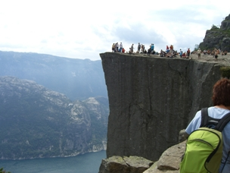

Marquee Tag

**Marquee** <MARQUEE>:This tag is used to display text in a scrolling way on Webpage. You must have seen many sites using this moving text, it does grab some attention of the user.  
The attributes of this tag are Direction, Behavior and Loop.  
1) Direction: It Specifies whether the Text scrolls from right to left or left to right.  
2) Behavior: Behavior has 3 values scroll, alternate and slide. Scroll causes moving of text from left to right or vice versa. Alternate causes text to bounce back and forth between the margins  
Marquee slides through the webpage because of slide value. The default value is scroll.  
3) Loop: it Tells the number of times marquee should scroll.

Example:  
Below are few examples of marquee tag just copy in editor and save as .html to view the effects

Example : Example using Behavior : Alternate

01.<html>

02.<head>

03.<title>   My web page using marquee </title></head>

04.<body>

05.<font size="6"

06.face="Times New Roman"

07.color=blue>

08.<marquee width=100%

09.behavior=alternate

10.bgcolor=pink >

11.This is an example of a marquee using alternate as behavior...

12.</marquee></font>

13.</body>

14.</html>

Example using Behavior :Slide

01.<html>

02.<head>

03.<title>   My web page using marquee </title></head>

04.<body>

05.<font size="5"

06.face="courier"

07.color=pink>

08.<marquee width=100%

09.behavior=slide

10.bgcolor=blue >

11.This is an example of a marquee using slide as behavior...

12.</marquee></font>

13.</body>

14.</html>

Example using Behavior :scroll

01.<html>

02.<head>

03.<title>   My web page using marquee </title></head>

04.<body>

05.<font size="5"

06.face="courier"

07.color=pink>

08.<marquee width=100%

09.behavior=scroll

10.bgcolor=blue

11.loop=3>

12.This is an example of a marquee using scroll as behavior...

13.</marquee></font>

14.</body>

15.</html>

The difference between slide, scroll and alternate is , in scroll the text continuously scrolls from one end to another in the same direction but in slide text starts scrolling from one end and stops at other end and in alternate scrolls back and forth.

Example using Direction:

01.<html>

02.<head>

03.<title>   My web page using marquee </title></head>

04.<body>

05.<font size="5"

06.face="courier"

07.color=white>

08.<marquee width=100%

09.behavior=scroll

10.direction=right

11.bgcolor=red >

12.This is an example of a marquee using direction from left to right...

13.</marquee></font>

14.</body>

15.</html>

Example:To scroll the text in upwards direction

1.<html>

2.<head>

3.<title> marquee</title></head>

4.<body>

5.<marquee  behavior="scroll" direction="up">

6.This is an example of marquee scrolling upwards</marquee>

7.</body>

8.</html>

Example:To scroll the text in downwards direction

1.<html>

2.<head>

3.<title> marquee</title></head>

4.<body>

5.<marquee  behavior="scroll" direction="down">

6.This is an example of marquee scrolling downwards</marquee>

7.</body>

8.</html>

Example: To scroll text in different speeds.

01.<html>

02.<head>

03.<title> marquee</title></head>

04.<body>

05.<marquee behavior="scroll" direction="left" scrollamount="1">scroll text in slow speed</marquee>

06.<marquee behavior="scroll" direction="left" scrollamount="8">scroll text in medium speed</marquee>

07.<marquee behavior="scroll" direction="left" scrollamount="18">scroll text in fast  speed</marquee>

08.</body>

09.</html>

Example:To Scroll images

1.<html>

2.<head>

3.<title> marquee</title></head>

4.<body>

5.<marquee behavior="scroll" direction="left" scrollamount = "3" >

6.<img src="D:\My Documents\learn3.gif" alt="smile" /></marquee>

7.</body>

8.</html>

in the above code write the location of the image  
i.e <img src=”loaction of your image”>

Example:To scroll image and text together.

01.<html>

02.<head>

03.<title> marquee</title></head>

04.<body>

05.<marquee behavior="scroll" direction="left" scrollamount="3">

06.<img src="D:\My Documents\learn3.gif" alt="smile" />

07.<p>This is marquee using scrolling text and image </p>

08.</marquee>

09.</body>

10.</html>

in the above code write the location of the image  
i.e <img src=”loaction of your image”>

Using scroll delay  
Here scroll delay is the time that a marquee should wait before the next jump.

Example:

1.<html>

2.<head>

3.<title> my HTML webpage</title></head>

4.<body>

5.<marquee behavior="scroll" direction="left" scrollamount="80" scrolldelay="500">

6.Your text goes here </marquee>

7.</body>

8.</html>

**HTML Images**  
To embed or add an image to the webpage we use image tag  
Example:

1.<html>

2.<head>

3.<title>   My web page using image</title></head>

4.<body>

5.<img scr="<http://www.codingmanuals.com/wp-content/uploads/2010/08/wp.jpg>"

6.alt="inspiring quote"/>

7.</body>

8.</html>

**Hyperlinks**  
Hyperlinks commonly used as links are used to toggle between the Web Pages.  
To create a hyperlink, href attribute is used and the url is given as input to the attribute.

Example:

1.<html>

2.<head>

3.<title>   My web page using hyperlink </title></head>

4.<body>

5.<a href="<http://www.codingmanuals.com/html-tutorials/formatting-tags/>">

6.Learn Formatting </a>

7.</body>

8.</html>

**HTMLComments**  
Comments gives a brief description of code which makes it easier to understand.Comments are never displayed on browser, those are only for user’s understanding.Comments are written as:  
Example:

1.<html>

2.<head>

3.<title>   comment example</title></head>

4.<body>

5.<p>This is how a comment can be written

6.<!--this is an example of comment -->

7.</body>

8.</html>

**Unit-IV**

HTML Tables

Tables are defined with the <table> tag.

A table is divided into rows with the <tr> tag. (tr stands for table row)

A row is divided into data cells with the <td> tag. (td stands for table data)

A row can also be divided into headings with the <th> tag. (th stands for table heading)

The <td> elements are the data containers in the table.

The <td> elements can contain all sorts of HTML elements like text, images, lists, other tables, etc.

The width of a table can be defined using CSS.

Example

<table style="width:300px">  
<tr>  
  <td>Jill</td>  
  <td>Smith</td>   
  <td>50</td>  
</tr>  
<tr>  
  <td>Eve</td>  
  <td>Jackson</td>   
  <td>94</td>  
</tr>  
</table>

**HTML Table Example:**

|  |  |  |
| --- | --- | --- |
| **Firstname** | **Lastname** | **Points** |
| Jill | Smith | 50 |
| Eve | Jackson | 94 |
| John | Doe | 80 |
| Adam | Johnson | 67 |

**An HTML Table with a Border Attribute**

If you do not specify a border for the table, it will be displayed without borders.

A border can be added using the border attribute:

Example

<table border="1" style="width:300px">  
<tr>  
  <td>Jill</td>  
  <td>Smith</td>   
  <td>50</td>  
</tr>  
<tr>  
  <td>Eve</td>  
  <td>Jackson</td>   
  <td>94</td>  
</tr>  
</table>

To add borders with CSS, use the border property:

Example

<style>  
table,th,td  
{  
border:1px solid black;  
}  
</style>

Remember to define borders for both the table and the table cells.

An HTML Table with Collapsed Borders

If you want the borders to collapse into one border, add border-collapse to your CSS:

Example

<style>  
table,th,td  
{  
border:1px solid black;  
border-collapse:collapse  
}  
</style>

An HTML Table with Cell Padding

Cell padding specifies the space between the cell content and its borders.

If you do not specify a padding, the table cells will be displayed without padding.

To set the padding, use the CSS padding property:

Example

th,td  
{  
padding:15px;  
}

HTML Table Headings

Table headings are defined with the <th> tag.

By default, all major browsers display table headings as bold and centered:

Example

<table style="width:300px">  
<tr>  
  <th>Firstname</th>  
  <th>Lastname</th>   
  <th>Points</th>  
</tr>  
<tr>  
  <td>Eve</td>  
  <td>Jackson</td>   
  <td>94</td>  
</tr>  
</table>

To left-align the table headings, use the CSS text-align property:

Example

th  
{  
text-align:left;  
}

An HTML Table with Cell Spacing

Cell spacing specifies the space between the cells.

To set the cell spacing for the table, use the CSS border-spacing property:

Example

table  
{  
border-spacing:5px;  
}

HTML Table Tags

|  |  |
| --- | --- |
| **Tag** | **Description** |
| [<table>](http://www.w3schools.com/tags/tag_table.asp) | Defines a table |
| [<th>](http://www.w3schools.com/tags/tag_th.asp) | Defines a header cell in a table |
| [<tr>](http://www.w3schools.com/tags/tag_tr.asp) | Defines a row in a table |
| [<td>](http://www.w3schools.com/tags/tag_td.asp) | Defines a cell in a table |
| [<caption>](http://www.w3schools.com/tags/tag_caption.asp) | Defines a table caption |
| [<colgroup>](http://www.w3schools.com/tags/tag_colgroup.asp) | Specifies a group of one or more columns in a table for formatting |
| [<col>](http://www.w3schools.com/tags/tag_col.asp) | Specifies column properties for each column within a <colgroup> element |
| [<thead>](http://www.w3schools.com/tags/tag_thead.asp) | Groups the header content in a table |
| [<tbody>](http://www.w3schools.com/tags/tag_tbody.asp) | Groups the body content in a table |
| [<tfoot>](http://www.w3schools.com/tags/tag_tfoot.asp) | Groups the footer content in a table |

<!DOCTYPE html>

<html>

<head>

<style>

table, th, td

{border:1px solid black;

padding:5px;}

table

{border-spacing:15px;}

</style>

</head>

<body>

<table style="width:300px">

<tr>

<td>Jill</td>

<td>Smith</td>

<td>50</td>

</tr>

<tr>

<td>Eve</td>

<td>Jackson</td>

<td>94</td>

</tr>

<tr>

<td>John</td>

<td>Doe</td>

<td>80</td>

</tr></table>

<p>Try to change the spacing to 5px.</p>

</body>

</html>

|  |  |  |
| --- | --- | --- |
| Jill | Smith | 50 |
| Eve | Jackson | 94 |
| John | Doe | 80 |

**Unit-V**

# Frames

Frames provide a way to show several documents in the browser window at once. Using frames lets you effectively break up your browser window into several smaller windows.

## Simple Frames

Presume you want a layout like this, with a file named title.html displayed in the top 20% of the window and content.html displayed in the bottom part:

|  |
| --- |
| **title.html** |
| **content.html** |

To achieve this effect, you will need a third document, called the **frameset document**, which specifies how the frames fit together. Your frameset document will look like this, with line numbers for reference.

1 <!DOCTYPE html PUBLIC "-//W3C//DTD XHTML 1.0 Frameset//EN"

2 "http://www.w3.org/TR/xhtml1/DTD/xhtml1-frameset.dtd">

3 <html xmlns="http://www.w3.org/1999/xhtml">

4 <head>

5 <title>Frameset 1</title>

6 </head>

7

8 <frameset rows="20%, 80%">

9 <frame src="title.html" />

10 <frame src="content.html" />

11

12 <noframes>

13 <body>

14 <p>Sorry, your browser does not support frames.</p>

15 </body>

16 </noframes>

17

18 </frameset>

19

20 </html>

Specify a message to display in case the user’s browser does not support frames. This is where you put the <body> of your document, strange as it may seem.

## Frame Attributes

Chapter fifteen discusses the attributes you may use in a <frame />.

## Complex (Nested) Framesets

Let’s say you want a frameset that looks like this. This is not an example of particularly good design; there are diminishing returns the more complex your framesets become. This example is here because it shows that the technique works in complex cases, so it will certainly work in simple cases.

|  |  |  |
| --- | --- | --- |
| **a.html** | **b.html** | |
| **c.html** | |
| **d.html** | **e.html** |

The <frame> tag is not supported in HTML5.

The <frame> tag defines one particular window (frame) within a <frameset>.

Each <frame> in a <frameset> can have different attributes, such as border, scrolling, the ability to resize, etc.

**Note:** If you want to validate a page containing frames, be sure the [<!DOCTYPE>](http://www.w3schools.com/tags/tag_doctype.asp) is set to either "HTML Frameset DTD" or "XHTML Frameset DTD".

Example

A simple three-framed page:

<frameset cols="25%,50%,25%">  
  <frame src="frame_a.htm">  
  <frame src="frame_b.htm">  
  <frame src="frame_c.htm">  
</frameset>

Differences Between HTML 4.01 and HTML5

The <frame> tag is not supported in HTML5.

Differences Between HTML and XHTML

In HTML, the <frame> tag has no end tag. In XHTML, the <frame> tag must be properly closed.

Optional Attributes

|  |  |  |
| --- | --- | --- |
| Attribute | Value | Description |
| [frameborder](http://www.w3schools.com/tags/att_frame_frameborder.asp) | 0 1 | Not supported in HTML5. Specifies whether or not to display a border around a frame |
| [longdesc](http://www.w3schools.com/tags/att_frame_longdesc.asp) | URL | Not supported in HTML5. Specifies a page that contains a long description of the content of a frame |
| [marginheight](http://www.w3schools.com/tags/att_frame_marginheight.asp) | pixels | Not supported in HTML5. Specifies the top and bottom margins of a frame |
| [marginwidth](http://www.w3schools.com/tags/att_frame_marginwidth.asp) | pixels | Not supported in HTML5. Specifies the left and right margins of a frame |
| [name](http://www.w3schools.com/tags/att_frame_name.asp) | text | Not supported in HTML5. Specifies the name of a frame |
| [noresize](http://www.w3schools.com/tags/att_frame_noresize.asp) | noresize | Not supported in HTML5. Specifies that a frame is not resizable |
| [scrolling](http://www.w3schools.com/tags/att_frame_scrolling.asp) | yes no auto | Not supported in HTML5. Specifies whether or not to display scrollbars in a frame |
| [src](http://www.w3schools.com/tags/att_frame_src.asp) | *URL* | Not supported in HTML5. Specifies the URL of the document to show in a frame |

HTML <frameset> Tag. Not Supported in HTML5.

Example

A simple three-framed page:

<frameset cols="25%,*,25%">  
  <frame src="frame_a.htm">  
  <frame src="frame_b.htm">  
  <frame src="frame_c.htm">  
</frameset>

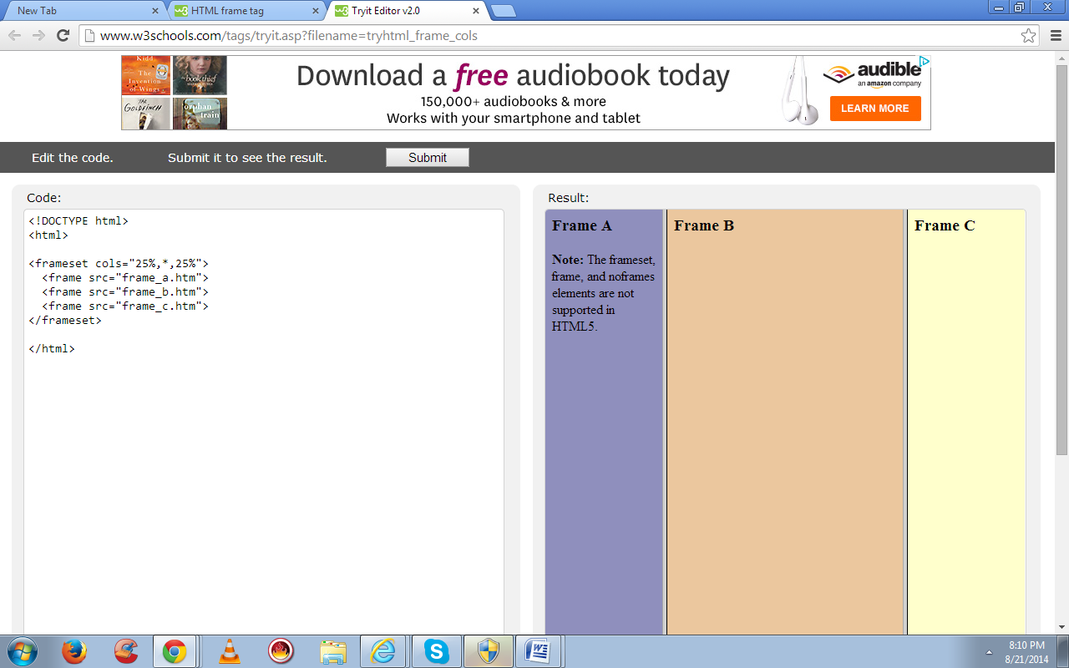

Definition and Usage

The <frameset> tag is not supported in HTML5.

The <frameset> tag defines a frameset.

The <frameset> element holds one or more [<frame>](http://www.w3schools.com/tags/tag_frame.asp) elements. Each <frame> element can hold a separate document.

The <frameset> element specifies HOW MANY columns or rows there will be in the frameset, and HOW MUCH percentage/pixels of space will occupy each of them.

**Note:** If you want to validate a page containing frames, be sure the [<!DOCTYPE>](http://www.w3schools.com/tags/tag_doctype.asp) is set to either "HTML Frameset DTD" or "XHTML Frameset DTD".

Differences Between HTML 4.01 and HTML5

The <frameset> tag is not supported in HTML5.

Differences Between HTML and XHTML

NONE

Optional Attributes

|  |  |  |
| --- | --- | --- |
| **Attribute** | **Value** | **Description** |
| [cols](http://www.w3schools.com/tags/att_frameset_cols.asp) | *pixels % \** | Not supported in HTML5. Specifies the number and size of columns in a frameset |
| [rows](http://www.w3schools.com/tags/att_frameset_rows.asp) | *pixels % \** | Not supported in HTML5. Specifies the number and size of rows in a frameset |

[Frameset with noresize="noresize"](http://www.w3schools.com/tags/tryit.asp?filename=tryhtml_frame_noresize)  
How to use the "noresize" attribute. The frames are not resizable. Move the mouse over the borders between the frames and notice that you can not move the borders.

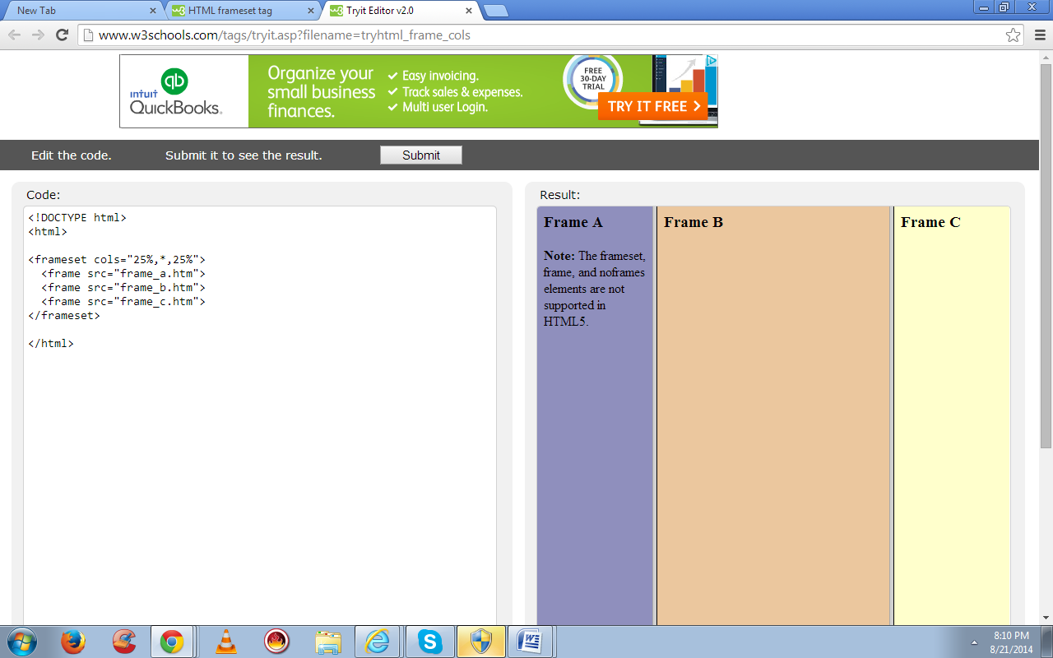

**Linking Among Frames**

Let's set up a very typical frameset, with index on the left and content on the right:

|  |  |
| --- | --- |
| **index.html** | **content.html** |

Here's the frameset that we need:

<frameset cols="20%, 80%">

<frame src="index.html" />

<frame src="content.html /">

<noframes>

<p>Get a better browser.</p>

</noframes>

</frameset>

In the index file, we have these links:

<ul>

<li><a href="http://www.linux.org/">Linux.org</a></li>

<li><a href="http://www.w3.org/">World Wide Web consortium</a></li>

<li><a href="http://slashdot.org/">SlashDot - News for Nerds</a></li>

</ul>

And our content file has this as its starting value:

<p>Please click a link on the left to see that site.</p>

HTML Forms

HTML forms are used to pass data to a server.

An HTML form can contain input elements like text fields, checkboxes, radio-buttons, submit buttons and more. A form can also contain select lists, textarea, fieldset, legend, and label elements.

The <form> tag is used to create an HTML form:

<form>  
.  
*input elements*  
.  
</form>

HTML Forms - The Input Element

The most important form element is the <input> element.

The <input> element is used to select user information.

An <input> element can vary in many ways, depending on the type attribute. An <input> element can be of type text field, checkbox, password, radio button, submit button, and more.

The most common input types are described below.

Text Fields

<input type="text"> defines a one-line input field that a user can enter text into:

<form>  
First name: <input type="text" name="firstname"><br>  
Last name: <input type="text" name="lastname">  
</form>

How the HTML code above looks in a browser:

Top of Form

First name:   
Last name: 

Bottom of Form

**Note:** The form itself is not visible. Also note that the default width of a text field is 20 characters.

Password Field

<input type="password"> defines a password field:

<form>  
Password: <input type="password" name="pwd">  
</form>

How the HTML code above looks in a browser:

Top of Form

Password: 

Bottom of Form

**Note:** The characters in a password field are masked (shown as asterisks or circles).

Radio Buttons

<input type="radio"> defines a radio button. Radio buttons let a user select ONLY ONE of a limited number of choices:

<form>  
<input type="radio" name="sex" value="male">Male<br>  
<input type="radio" name="sex" value="female">Female  
</form>

How the HTML code above looks in a browser:

Top of Form

Male  
Female

Bottom of Form

Checkboxes

<input type="checkbox"> defines a checkbox. Checkboxes let a user select ZERO or MORE options of a limited number of choices.

<form>  
<input type="checkbox" name="vehicle" value="Bike">I have a bike<br>  
<input type="checkbox" name="vehicle" value="Car">I have a car   
</form>

How the HTML code above looks in a browser:

Top of Form

I have a bike  
I have a car

Bottom of Form

Submit Button

HTML <textarea> Tag

Example

An HTML text area:

<textarea rows="4" cols="50">  
At w3schools.com you will learn how to make a website. We offer free tutorials in all web development technologies.   
</textarea>

Definition and Usage

The <textarea> tag defines a multi-line text input control.

A text area can hold an unlimited number of characters, and the text renders in a fixed-width font (usually Courier).

The size of a text area can be specified by the cols and rows attributes, or even better; through CSS' height and width properties.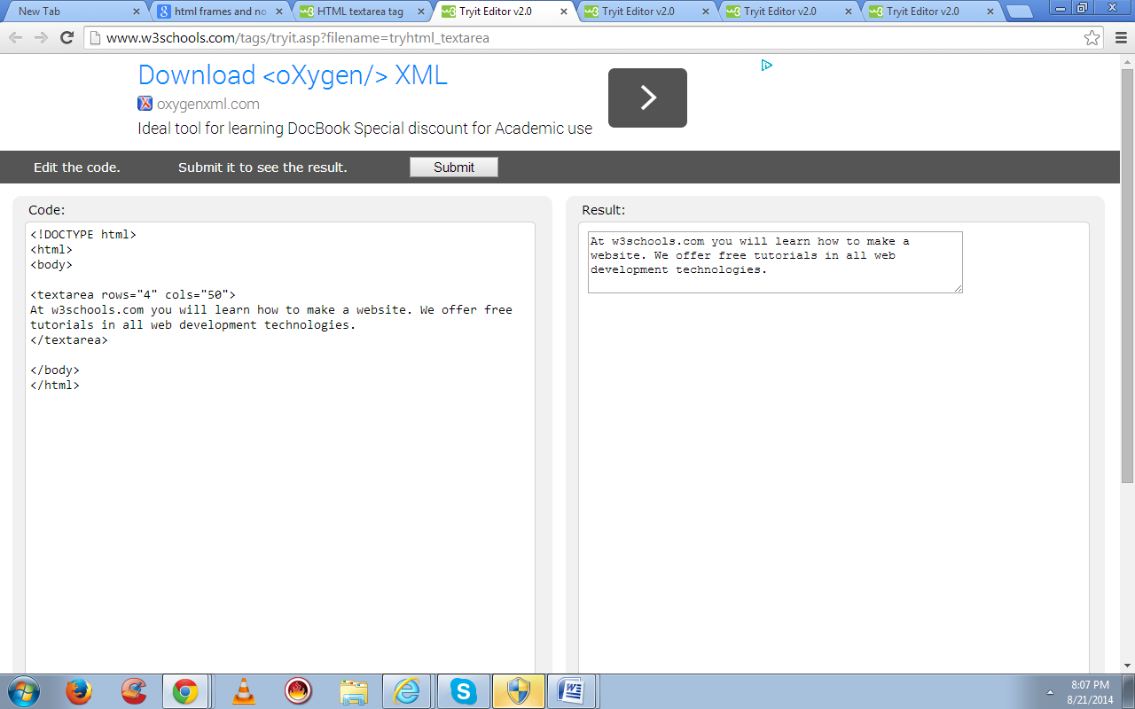

**HTML <select> Tag**

Example

Create a drop-down list with four options:

<select>  
  <option value="volvo">Volvo</option>  
  <option value="saab">Saab</option>  
  <option value="mercedes">Mercedes</option>  
  <option value="audi">Audi</option>  
</select>

**Definition and Usage**

The <select> element is used to create a drop-down list.

The [<option>](http://www.w3schools.com/tags/tag_option.asp) tags inside the <select> element define the available options in the list.

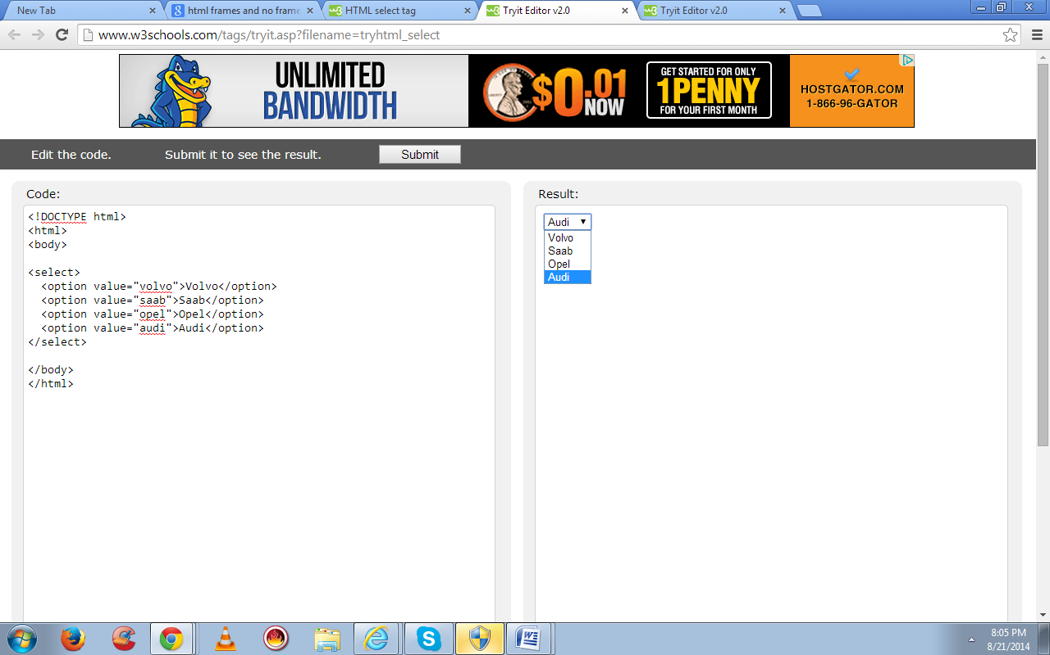

HTML <option> Tag

Example

A drop-down list with four options:

<select>  
  <option value="volvo">Volvo</option>  
  <option value="saab">Saab</option>  
  <option value="opel">Opel</option>  
  <option value="audi">Audi</option>  
</select>

Definition and Usage

The <option> tag defines an option in a select list.

<option> elements go inside a [<select>](http://www.w3schools.com/tags/tag_select.asp) or [<datalist>](http://www.w3schools.com/tags/tag_datalist.asp) element.

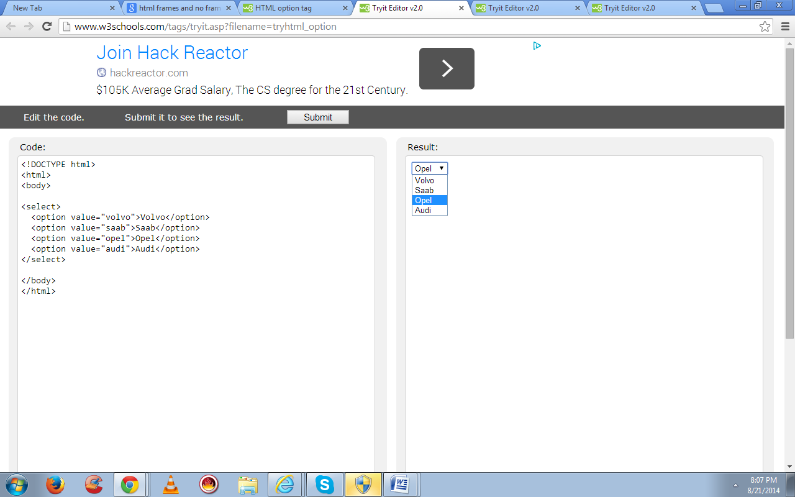

<input type="submit"> defines a submit button.

A submit button is used to send form data to a server. The data is sent to the page specified in the form's action attribute. The file defined in the action attribute usually does something with the received input:

<form name="input" action="demo_form_action.asp" method="get">  
Username: <input type="text" name="user">  
<input type="submit" value="Submit">  
</form>

How the HTML code above looks in a browser:

Top of Form

Username: 

Bottom of Form

If you type some characters in the text field above, and click the "Submit" button, the browser will send your input to a page called "demo_form_action.asp". The page will show you the received input.